1. Select the email address which you want to delete.
2. Go to Online panel – create new Interactive site with Sign in tab and Contact (FirstName and LastName only)

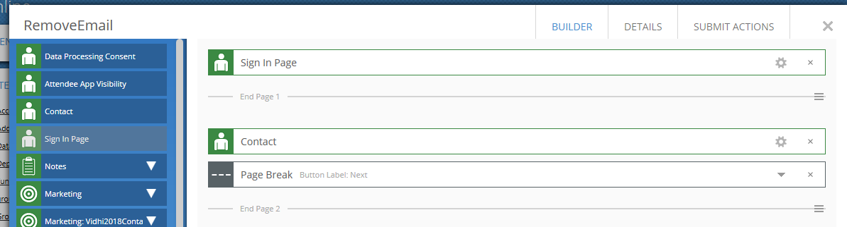

1. Now go to Details option – click on the URL – Forgot the password – Insert the email address you want to remove in the Forgot password box.

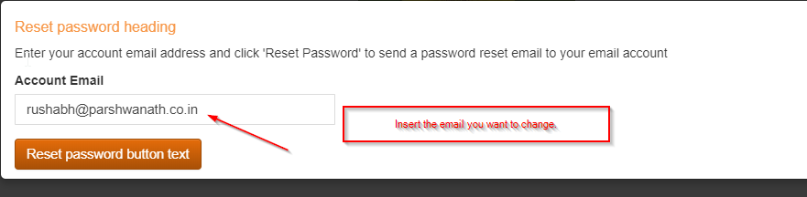

1. Meanwhile, keep the client build open – go to their communication – in Outbox you will see the email for password resent will be sent.
2. Select the email from Outbox and QUEUE the email from outbox. “DO NOT SEND THE EMAIL FORM OUTBOX”
3. Once the email has been QUEUED, go to QUEUE section – select the email – click on the change Password link – change the password.
4. Now using the same email (clients email) and password (which you have reset it) sign in into the Interactive site which you just created.
5. Type in First Name and Last Name and submit the test record.
6. Now go to EventsAIR build (which will be clients) select the test record you just submitted via Interactive site.
7. Go to Online account and change the ONLINE ACCOUNT email address to something else. (you can also change the email and delete the test record)
8. Now delegate will able to use the same email address as it has been deleted from the event.